Keeler Park
6/20/24
Teachers Institute of Philadelphia
Seminar: The Soviet Century

The Pulse of the Land: Using the Arts to Teach About War

Unit Content

Abstract: The Pulse of the Land focuses on developing students understanding of war and conflict as it relates to shaping history. The unit seeks to engage students with various forms of art as primary sources in order to evaluate the human toll and cost of warfare as well as the range of emotions that accompany the experience of living through conflict. Students will interact with a variety of primary and secondary sources in order to evaluate their own lived experience and its relation to war around the globe and ultimately the unit will culminate with students creating an original poem or song that captures an aspect of the war experience.

Key words: history, war, conflict, art, poetry, literary analysis, social studies, culture, emotion, social-emotional learning, military, military history, primary source, secondary source, world history, creative writing

I am a history teacher at an all girls high school in the School District of Philadelphia. While my school is not coed, we are a magnet school and we serve an incredibly diverse range of student backgrounds, languages, and cultural practices. We teach students who’s families originate in the Caribbean Islands, Eastern Europe, Southeast Asia, the Middle East, and of course Philadelphia. This wide range of backgrounds makes being a world history teacher an incredibly enriching and challenging experience. On one hand, I have to work hard to expand the scope of the curriculum to teach about such a wide variety of cultures. But on the other hand, I can always lean on the cultural knowledge and experience of my students to guide classroom discussions.
With that said, the world history curriculum at my school is often detached from students lived experiences, and I worry that the human element of history can get lost when so much time is spent cramming the curriculum with facts relevant to AP assessments. My students bring a wealth of knowledge and experiences into the classroom which do not get mined, and are taught to view history from what I believe is an overly clinical perspective. I also feel that the history classroom is too often isolated and siloed, when in reality there is a wealth of resources from the language arts or visual arts classrooms that can and should be viewed as historical resources, too. This unit will seek to disrupt these issues by situating primary sources from the arts at its center, utilizing them to examine the human element of war and conflict, and drawing on student experiences and histories to further our understanding of history, society, and one another.

Standards: This unit is aligned with the Pennsylvania Department of Education Academic Standards for Social Studies. These standards are designed to support instruction and development of content knowledge related to geography, history, sociology, and a variety of other domains. The goal of this unit is to expand upon PDE standards for Social Studies by introducing critical discussions of race in history.

Standard - 7.1.9.B
Explain and locate regions and their shared connections as defined by physical and human features.

Standard - 8.1.9.A
Compare patterns of continuity and change over time, applying context of events.

Standard - 8.1.9.B
Compare the interpretation of historical events and sources, considering the use of fact versus opinion, multiple perspectives, and cause and effect relationships.

Standard - 8.1.9.C
Construct research on a historical topic using a thesis statement and demonstrate use of appropriate primary and secondary sources.

Standard - 8.4.9.D
Analyze how conflict and cooperation among groups and organizations have influenced the history and development of the world.

Bibliography
The following resources were used in researching/writing this unit:
- Winn, James Anderson, The Poetry of War. Cambridge: Cambridge University Press, 2008.
- Sylvester, Christine. Experiencing War. London: Routledge, 2011.
- Schrader, Benjamin. “Living War, Writing War, Teaching War.” Critical Military Studies 9, no. 1 (2023): 59–74.
- Toros, Harmonie, Daniel Dunleavy, Joe Gazeley, Alex Guirakhoo, Lucie Merian, and Yasmeen Omran. “‘Where Is War? We Are War.’ Teaching and Learning the Human Experience of War in the Classroom.” International studies perspectives. 19, no. 3 (2018): 199–217.
- Gross, Jan T., Revolution From Abroad: The Soviet Conquest of Poland's Western Ukraine and Western Belorussia - Expanded Edition. Princeton, NJ :: Princeton University Press, 2021.
- Mark Newman. 2014. Vital Witnesses : Using Primary Sources in History and Social Studies. Lanham: Rowman & Littlefield Publishers.
- Peters, William. 2020. “Film in History Education: A Review of the Literature.” The Social Studies 111 (6): 275–95.
- Sospedra-Roca, Rafael, Francesc Xavier Hernàndez-Cardona, and Mar Hernàndez-Pongiluppi. 2022. “Digital Iconography, Conflict Heritage, and the Teaching of History: The Case of the Spanish Civil War.” Cogent Education 9 (1)
- Nathans, Benjamin.

Objectives
This unit is designed for a 9th grade World History course, however it could also be applicable to any history class with a curriculum that requires students to learn about/discuss wars and conflicts throughout history. There are no prerequisites to this unit, however it is expected that this unit would be taught towards the beginning of the year as a means to give students a humanizing lens through which they can view the history of war and conflict. This unit is designed for a 45 minute daily period schedule, but can be revised for an alternate schedule as needed.

The objectives for this unit include the following:
- Explore and define what it means to be “at war”
- Analyze how wars and conflict affect different levels of society from economic, political, and emotional perspectives
- Discuss and analyze poetry, artwork, and film that capture the lived experience of war/conflict
- Complete a series of document based questions pulling from primary and secondary sources
- Draft an original thesis and support it using evidence from document based questions

Unit Content
Background

Why Teach War?
One of the most consistent through lines through the history of humanity is the ebb and flow of conflict. It is impossible to engage with the history of a place or a people without considering the ways that conflicts, whether direct or indirect, have played a role in shaping things. History classes are rife with discussions of conflict: civil wars, world wars, genocides, compulsory military conscription, colonial violence, wars over resources, wars over ideas, the list goes on. While nearly any student could tell you that a civil war is when a country goes to war with itself, or that a world war involves powers from around the globe and typically has a large death toll, rarely do students take time to think about what it actually means, from a human perspective, to be at war.
As stated by military historian Benjamin Schrader, when war is “taught” in the classroom, “it [is] usually as a peripheral object.” Indeed, Schrader found that, even at the college level, students are rarely required to engage with war beyond the cursory level. Students may learn how many people died over the course of a (usually arbitrary) period of time, they may learn about the political reactions to this loss of life, but almost never are they given time and space to work through what it means for a people to face conflict— emotionally, morally, psychologically, or otherwise. Whether this is due to “a lack of expertise and knowledge on how to engage with these concepts,” or, “a lack of access by researchers,” the fact remains that students are not given a fair chance to evaluate the weight of events which shape so much of our current world.
Now, more than ever, it is essential to reverse this trend. Between the war in Ukraine, the conflict in Gaza, or the troubling behavior of powers like China or America towards their less powerful neighbors, students need to be able to contextualize conflict as more than just a set of data, or events that happened at some point in the distant past. While the tension on college campuses regarding the Israel-Gaza conflict is well documented, high schoolers are also intensely focused on the unfolding events as evidenced by large scale student walkouts in cities across America. This shows us that these conversations are happening in the lives of our high school students— but unfortunately little space is given for them in classrooms, robbing us of a chance to steer those discussions.
Clearly, students are feeling the weight of living in an ever increasingly polarized society as our nations political sphere, social norms, and even geography are plunged deeper into entrenched, dogmatic beliefs. Perhaps not ironically, these same forms of polarization are consistently present throughout historical times of revolution. Though it is impossible to say yet whether or not we are living in a revolutionary time, it seems obvious that we should be preparing our students for the possibility of great change in society. In order to do this, we must familiarize students with the “social reality” of conflict in order to find “the potential paths to conflict resolution and transformation,” that will be necessary to create a positive future. Leaving these issues outside of the classroom only serves to create students who are ill-equipped or simply unable to deal with the realities of polarization and global conflict.
Ultimately it is essential to teach war because, if we want our students to take the necessary critical lens towards the contemporary world that is so necessary, they need an accurate formwork through which they can understand how we got here. In the words of historian Benjamin Nathans in regards to the importance of understanding the perspective of Soviet dissidents, “we can begin to fathom the history they made only if we consider the history that made them.” The implications of this idea are much larger than Soviet dissidents. Indeed, to be able to understand the contemporary order of the world and its major players, we must be willing to look at war and conflicts, as these factors have shaped the past and thus the present. We can use the history of conflict as a means for teaching the cause and effect relationship that characterizes the entire history of humanity.

Locating War in the Classroom
Perhaps one reason why war is not often covered beyond the factual level is the fact that it is— by its very nature, violent, cold, confusing, and upsetting. As teachers, we don’t want to ruin anyones day, or make our classroom into a place that feels uncomfortable. After all, many of us are teaching students who, at least in theory, aren’t even allowed to watch most Hollywood movies about war. There is a certain logic to the idea that wading deep into the waters of violent conflict is surely going to isolate, upset, or at the very least be beyond comprehension for kids who know little about the harsh realities of the “real world.” And yet, this idea turns out to be untrue and unfounded.
When teaching a college class aimed at removing the distance between war and modern conceptions of “western nations,” sociologist Hermione Toros was surprised to find students push back on the idea that they don’t have personal, meaningful understandings of what it means to be at war. True as it may be for many that “he ‘West’ has long been presented as a peaceful place: war happens elsewhere or a long time ago,” it is also true that many of our students come from backgrounds where war is a not so distant part of their familial or ethnic history. In this sense, teaching about war can actually be a fantastic way to situate these students as knowers and create a democratic classroom where knowledge flows from top down and bottom up. As Toros notes, “war experience cannot only be about what happens over there, to others, or long ago in this supposed ‘peaceful’ West we inhabit.” Rather, war must be examined deeply, beyond the surface level facts, and as something that our students possess some degree of experience or knowledge about before they even arrive in the classroom. Toros found in her research that utilizing narrative and reflective writing about war and the war experience has a range of benefits for learners— whether their experience with war is first hand, second hand, or even if they have not experienced war in a way that has personally effected them.
First and foremost, writing about ones direct or indirect experiences with war and conflict creates space for students to push back on the problematic notion of our “lands as ‘civilized lands of peace’ where violent enmities have been overcome by ‘our superior civilization.’” When we open up conversations about war and conflict in the classroom that extend beyond textbook style retellings of dates and statistics, we engage students in a critical process of self-evaluating themselves and their national identity against the narratives they have been told. As demonstrated in Toros’ work, the narratives produced by students can be powerful in their rebukes of western-centric thought. Similarly, engaging students in discussions, narratives, and reflections on war experience is a “democratization of war experience,” which, “creates a political responsibility in us as retainers of war experience.” When students can discuss and hear one another’s experiences and interpretations, they do the important work of understanding how the past has shaped the present, and uphold the stories that brought us here. Understandable as the instinct to not engage students with the type of content that is central to war and conflict, the fact is that shying away from these discussions only serves to limit exciting possibilities to build classroom culture and re-evaluate common understandings of history.

Art: The Pulse of the People
Primary sources have anchored social studies classrooms for decades— and for good reason. Because they are inherently subjective and decidedly not neutral, they allow teachers to teach beyond the text, and probe deeper questions about the skills required to be a good historian. They also have the unique benefit of placing students into the real perspectives of people throughout history, giving them a quality of truth that is often lost in retroactive summaries of a place or time. Of course, none of this is new information, and classrooms across the country utilize primary sources as engines for curricula. But, for all the classrooms focused on instruction through primary sources, there is a surprising lack of variety in the types of primary sources being implemented. Though “primary sources come in various sizes, shapes, and types,” in the classroom they routinely take the form of government documents, quotes from major historical figures, or images of popular culture. While there is nothing wrong with any of these sources, they don’t quite fit the bottom-up disposition towards instruction outlined above which this unit is seeking to capture. Instead, we must consider the variety that is at our disposal.
In his text, Vital Witnesses, curriculum specialist Mark Newman provides a very helpful graphic breaking down the wide array of things that can be considered as primary sources. The first distinction to consider is whether or not the source is what he calls a “human created document” or it can be considered “physical remains.” While the latter category offers possibilities for discussion, this unit is primarily concerned with human created documents. Within that category, we have print, visuals, media, and oral culture. Print being the largest and most commonly used category, it often takes on the form of records, documents, publications, etc. This unit will draw from text sources, but is decidedly more directed at the latter of the three categories and less traditional forms of historical text, as they tend to be underrepresented in classrooms and offer exciting possibilities outlined below.
Educator William Peters has provided an exhaustive and comprehensive overview of literature documenting the applications film has in the history classroom. Too often thought of as a “killing time” or “reward” activity, film has the power to “access moral-emotional capabilities, demonstrate difficult concepts … increase academic performance … or seek to determine students’ perception of visual media.” Clearly then, utilizing film as a method to engage students with studying and discussing war offers a variety of potential benefits which this unit seeks to harness. Visual arts also offer a host of benefits and have typically been seen as more legitimate sources of historical perspective. Interestingly though, digital arts and iconography may not enjoy the same status as historically valuable as say, an 18th century painting. However new research suggests that digital imagery can be a powerful tool to get students to begin thinking about history from new perspectives, even if that imagery simulates things that may not be historically accurate. While these findings are new, and we should be careful about implementing them too zealously, the point remains that there is much historical perspective to be gained from outside of traditional text sources.
Perhaps the most interesting window into historical perspectives, especially those regarding war and conflict, is poetry. Long cast as a genre that belongs firmly in English departments, poetry gives us essential insights to historical realities and helps to bring history to life. In his book, The Poetry of War, James Anderson Winn gives an extremely thorough overview of all of the ways that poetry is (and indeed always has been) the best medium through which we as human beings can understand the raw complexity of conflict. He states that “poems use memory to link the heroism of the moment to past tradition; they use prophecy to move beyond the violent moment to some consideration of its lasting meaning.” Not only is poetry deeply rooted in individual cultures and their unique styles, it also serves as a sort of litmus test for analyzing cultures to see what values poetry is used to underscore. Beyond this, poems just offer a deeper and richer perspective than things like textbooks or articles. Winn notes how “poets have given memorable expression to the personal motives that send men forth to fight … they also helped to shape the larger, more corporate ideas that nations and cultures invoke for warfare.” Considering that the goal of this unit is to escape the overly clinical, statistics driven way of studying and discussing war in the classroom, poetry offers the best means for achieving this. In a particularly poetic passage Winn summarizes why poetry will be key for this unit’s strategy for engaging students with conflict: “war dismembers bodies, scattering limb from limb. Poetry re-members these bodies and the people who lived in them, making whole in verse what was destroyed on the battlefield.”

Teaching Strategies

In this unit students will be required to engage in critical thinking, primary source analysis, z, and a in order to explore the concepts of war and conflict as well as how they impact human beings across the globe. Students will be guided through material with teacher led discussions to scaffold understanding, but as the unit progresses they will slowly be given more and more autonomy in how they interact with and analyze unit materials. In order to achieve this a number of instructional strategies will be employed. See the text below for a list of strategies, many of which have materials attached in Appendix A:

Graphic Organizers
In order to avoid and simplify an extensive note taking process, this unit will utilize graphic organizers as a means to deliver content to students. Specifically, the unit will make use of a modified Frayer Model for students to utilize when defining what it means to be “at war” which can be found in Appendix A (Figure 1). Additional graphic organizers will be utilized to frame group discussions and record significant insights for later use.

Primary Source Analysis
This unit will make heavy use of primary sources in the form of text, images, and video. Students will interact directly with these primary sources in order to act as historians and form a bottom-up perspective towards the history of human conflict. One of the important themes of this unit is reorienting student understanding of war and conflict as not just events that happened— but deeply impactful human tragedies which have effects that extend far beyond statistics and facts. Several key primary documents are attached in Appendix B.

Collaborative Close Read/Listen
A strategy for engaging students with poetry and music, collaborative close reading/listening encourages students to think deeply about abstract content. Students will meet as a group, preferably in a comfortable setting where they can see and hear one another with few obstructions. Students will be given a printed version of the poems and/or songs that will be discussed. Students will independently read a text selected by the teacher. After this period of independent reading, the teacher will read the poem aloud or play the song for a group listening session. Students will then be assigned specific sections of the text that they will be responsible for commenting on. After taking some time to gather thoughts, the teacher will lead students through a discussion of their thoughts. This process should start out relatively structured, but as students become more comfortable with the format discussions can become more freeform.

Annotation Bookmark
Annotation bookmarks are simple, effective tools which guiding students’ reading of primary and secondary sources with minimal interactions or interruptions. Essentially, students are given a bookmark with specific reading tasks to complete for each source, image, or resource. The content of an annotation bookmark can take many forms, it is unlikely that a critical reading bookmark for a history text will contain identical tasks to say, that of a science text, but this is one of the advantages: we can subtly encourage students to use specific strategies for specific types of text. An annotation book mark that can be used for this unit is attached in Appendix A (Figure X).

Document Based Questions
Document based questions are one of the essential tasks of contemporary history classrooms as they engage students with a collection of primary sources, ask students to do the work of a historian by analyzing the documents in tandem, and ultimately organize the docs based on thematic relevance or some other criteria. During this process, students are expected to utilize their knowledge from class as well as annotation strategies to keep their research organized. Document based questions, combined with a document based essay, are the culminating project of this unit. See Appendix A (Figure X) for the document based questions which accompany this unit.

Document Based Essay
After completing the document based questions, annotating them, and organizing them thematically, student will utilize their work in order to write an essay. Their essay will utilize the documents from the document based questions to answer a larger historical, open-ended question. For this unit, the DBQ essay will focus on the various impacts that war has on human beings politically, economically, and socially. Students will need to use all of the skills and resources from the unit to write this essay, so it will serve as the culminating assessment to gauge how well students have learned the material. A copy of the document based essay question and assignment overview are available in Appendix A (Figure X).

Exit ticket
Students will complete small writing/discussion tasks prior to completing a lesson. The purpose of these tasks is to check for students’ understanding and allow for teacher reflection. If necessary, these exit tickets may be factored in as grades.

Classroom Activities

Lesson 1

Lesson 1: Democratically Defining “At War”

Objective: Students will analyze primary sources and evaluate their own knowledge in order to articulate a consensus definition for what it means to be “at war.”

Materials and Resources:
- Modified Frayer Model (Appendix A, Figure 1)
- Reflection 1 (Appendix A, Figure 2)
- Impressions of War Source Collection (Appendix B, Figure 1)

Phase One: Begin the lesson by displaying on the board the prompt “think of a story or representation of war that you are familiar with, how does it depict war as a concept?” or something akin to it. Allow students some time to consider and write a response. As students are thinking, remind them of common mediums through which they may be familiar with depictions of war whether it be films, video games, news coverage, art, or anything else. Once students have had sufficient time to respond on paper, have them share out answers and keep track of their responses on the board, paying specific attention to the descriptions of how each source depicted war. As students give responses highlight common themes between their answers and encourage them to consider what a definition for being “at war” means. Encourage students to think about what being “at war” means beyond just fighting or the battlefield, offer them the example of how people at home must make financial sacrifices in times of war. After some discussion, plot a working definition of what it means to be “at war” on the board.

Phase Two: Once a rough definition has been recorded, remind students that the focus of this unit will be dealing with war and conflict on a human level, which will mean at times they will be engaging with materials that may be upsetting or distressing to some. If students feel uncomfortable or overwhelmed at any point, they are free to take a break or disengage with whatever material is causing them stress. With that stated, distribute to students (physically or digitally) the Impressions of War Source Collection (Appendix B, Figure 1) and the Frayer Model (Appendix A, Figure 1). Instruct students to look through the sources carefully, either with a partner of independently. As students look through the sources, they should complete the Frayer model. Remind them that completing the model will be essential to reassess their group definition at the end of the lesson. As students work, circulate the room to encourage and guide students through interaction.

Phase Three: After students have completed the Frayer model, turn their attention back towards the definition of what it means to be “at war” that they decided earlier. Ask them if there is anything that needs to be changed about the definition, or added onto it. As students add their thoughts, recollect a list of traits and important themes onto the board and negotiate a common definition with students. Have students copy the definition down into their notes and let them know they will continue to reference back to it throughout the unit.

Phase Four: To close the lesson, distribute the reflection exit ticket. Give students about five minutes to work on this silently and reflectively. As students exit the classroom, they should hand in their reflection at the front of the room.

Lesson 2

Lesson 2: Collaborative Close Reading

Objective: Students will analyze Siegfried Sassoon’s “The Death Bed” in order to reflect on a soldiers perspective of war.

Materials and Resources:
- Collaborative Close Reading Discussion Guide (Appendix A, Figure 3)
- Collaborative Close Reading Reflection (Appendix A, Figure 4)
- “The Death Bed” by Siegfried Sassoon (Appendix B, Figure 2)

Phase One: Begin the lesson by displaying on the board “what makes poetry different than other forms of writing? List 2-3 things.” or something akin to it. Allow students to take a few minutes to answer and, while they respond, remind them that poetry is a distinct writing form that has existed in some form or another since ancient history. Once students have had some time to list some ideas, allow them to share their lists to the class while you record them on the board. Once you have generated a list from the class, highlight answers which point to poetry’s ability to convey emotion, feeling, and tone. Inform students that for this unit, they will be looking at war and conflict through the lens of artistic expression as a means to get a more personal feeling for the way that these things impact peoples lives.

Phase Two: Arrange the room in a way that allows everyone to see one another unobstructed (if your classroom is not already set up in this way). Have students sit in desks and clear everything off except for a pencil. Once students are in place, pass out the collaborative close reading discussion guide worksheet and inform students to fill out the sheet as they read, listen, and discuss. Additionally, pass out a copy of “The Death Bed” to each student, informing them that the copy is theirs to keep and can be annotated as they see fit.

Phase Three: Inform students that they are about to participate in a collaborative close reading session. Before reading the poem, assign individual lines, words, or phrases to students. Inform them that they are responsible for explaining their interpretation of the line, word, or phrase they were assigned and how they fit into the poem as a whole. In other words, students will be responsible for explaining, in their own opinion, what their assigned section of the poem does for the piece as a whole. Once students are familiar with their part of the poem, read the poem aloud twice while students analyze. After students have been given some time to think, go around the circle and have students explain their thoughts and analysis. As the teacher, feel free to guide the discussion if it trails off or loses focus, but one of the goals here is to shift the onus of interpretation and analysis onto the students so that they can gain confidence in their own ideas. Remind students that there are no right or wrong answers. Additionally, encourage students to build on each other’s ideas and discussions.

Phase Four: Once everyone has discussed their part of the poem, pass out the collaborative close reading reflection on the poem. Inform students that they should consider all of the things that were said in the discussion when writing their reflection, and that they should think of their reflection as a way to wrap up and conclude the discussion that they were engaged in. Circulate the room as students reflect and allow them the rest of the class period to fully flesh out their thoughts.

Lesson 3

Lesson 3: Establishing a Framework

Objective: Students will analyze the factors which can trigger wars/revolutions in order to establish a framework for analysis that they can apply across history.

Materials and Resources:
- War and Conflict Analysis Framework (Appendix A, Figure 5)

Phase One: Begin the lesson by displaying on the board the prompt “What factors can cause an apple to fall from a tree?” Inform students that this is an abstract question for which they are encouraged to think outside of the box, but at the same time there are three specific factors that are “correct.” Circulate the room and give students some time to respond, allowing them to discuss with one another as they brainstorm. Once there has been sufficient time, begin allowing students to give their responses. For the purpose of this lesson and this framework, you are looking to highlight the factors of gravity (long term factors that are always at play), natural ripeness (medium term factors which require specific conditions), and human/natural interference (short term factors which are unpredictable but have important key players). Once students have gotten these three factors and they have been discussed, inform them that they will use this apple falling from a tree framework to analyze war and conflict for the rest of the unit.

Phase Two: Begin handing out the War and Conflict Analysis Framework as well as a link to Encyclopedia Brittanica’s entry on the French Revolution (https://www.britannica.com/event/French-Revolution). Inform students that while they read, they should be paying close attention to the factors which caused and shaped the French Revolution, making sure that they make notes for each aspect of the framework. Remind students that for wars, conflicts, and revolutions to occur, all three aspects must be present. Once students have the required materials, put a timer on the board for them to read and let them begin.

Phase Three: Circulate the room as the timer on the board counts down. Students will be reading and filling out their organizer for about twenty minutes, so make sure that you are available to answer any questions or give any necessary feedback during this time. Once the timer has gone down to the halfway point, give students a heads up that they should be half way there. Additionally, give students a five minute warning to wrap up and write down all of their thoughts before the reforming as a group. Once the time is over, bring the class back together for analysis.

Phase Four: On the board (preferably a Smartboard) project a blank version of the graphic organizer. Allowing the students to take the lead and guide what you write, begin to fill out the organizer. Ask students to consider as many possible aspects of the article as possible and take all factors leading up to the French Revolution into account. Additionally, encourage students to think of other conflicts they are familiar with from history, or even their own life, and how the factors that led up to it could fit neatly into our framework. Once the discussion has ran its course and you are satisfied with the conclusions students are drawing, close the lesson by having students complete an exit ticket answering the question, “Think of a conflict from your own life: list one long term factor, one medium term factor, and one short term factor which lead up to the conflict.”

Lesson 4

Lesson 4: Collaborative Close Listening

Objective: Students will analyze Country Joe and the Fish’s “Fixin’ to Die Rag” in order to analyze how the use of satire reflects the mood of civilians towards war.

Materials and Resources:
- Collaborative Close Listening Discussion Guide (Appendix A, Figure 6)
- Collaborative Close Listening Reflection (Appendix A, Figure 7)
- “Fixin’ to Die Rag” by Country Joe and the Fish lyrics (Appendix B, Figure 3)

Phase One: Begin the lesson by displaying on the board the prompt “what different forms/formats can a protest take?” or something akin to it. Allow students some time to respond and remind them that throughout history, human beings have protested or otherwise voiced discontent in a variety of mediums, methods, and contexts. Additionally, encourage them to consider protests/resistance movements that they see around the world today. Once students have had some time to write, have them share out answers and record them on the board. Highlight connections between answers or any time similar answers may come up to encourage everyone to get involved.

Phase Two: Arrange the room in a way that allows everyone to see one another unobstructed (if your classroom is not already set up in this way). Have students sit in desks and clear everything off except for a pencil. Once students are in place, pass out the collaborative close reading discussion guide worksheet and inform students to fill out the sheet as they read, listen, and discuss. Additionally, pass out a copy of “Fixin to Die Rag” to each student, informing them that the copy is theirs to keep and can be annotated as they see fit.

Phase Three: Inform students that they are about to participate in a collaborative close listing session. It will function similarly to the poetry reading from earlier in the unit, but will focus on music rather than poetry. Before playing the song, assign individual lines, words, or phrases to students. Inform them that they are responsible for explaining their interpretation of the line, word, or phrase they were assigned and how they fit into the song as a whole. Once students are familiar with their part of the song, play the song (or video of the live performance) twice while students analyze. After students have been given some time to think, go around the circle and have students explain their thoughts and analysis. As the teacher, feel free to guide the discussion if it trails off or loses focus, but one of the goals here is to shift the onus of interpretation and analysis onto the students so that they can gain confidence in their own ideas. With that said, encourage students to utilize the discussion guide and stick to the topic of satire within the song as much as possible. Additionally, encourage students to build on each other’s ideas and discussions.

Phase Four: Once everyone has discussed their part of the song, pass out the collaborative close listening reflection. Inform students that they should consider all of the things that were said in the discussion when writing their reflection, and that they should think of their reflection as a way to wrap up and conclude the discussion that they were engaged in. Circulate the room as students reflect and allow them the rest of the class period to fully flesh out their thoughts.

Lesson 5

Lesson 5: DBQ Analysis

Objective: Students will participate in a teacher led annotation session in order to practice and apply a framework for analyzing and annotating important course documents.

Materials and Resources:
- PAARTY Method Annotation Guide (Appendix A Figure 8)
- War and Conflict Poetry DBQ Set (Appendix A Figure 9)

Phase One: Begin the lesson by reviewing important annotation strategies with students. This can be accomplished with an entry question along the lines of “what factors should you consider when annotating a poem? What about a primary source?” Alternatively, direct instruction can be used if you want to ensure that students arrive at strategies to apply during the lesson. Ultimately the opening of this lesson depends on how confident students are answering DBQ questions and interacting with poetry, so use discretion. Through discussion or direct instruction, ensure that all students are clear that while they approach documents, they should be considering place and time, author, audience, reason, the main idea, and why the source has value. After all students are brought up to speed, hand out the War and Conflict Poetry DBQ set.

Phase Two: Inform students that they will be led through the first poem in order to get the ball rolling. Project Poem 1 onto the board (ideally a smart board or something that can be annotated while projected) and ask for a student to read it out loud to the class. Next, model the first two annotation strategies by noting the place/time of the document as well as the author. Continue to model the PAARTY strategy for students, slowly handing over the reins and asking for volunteers as you go. By the end of the PAARTY annotation, have students come up with a unified response to the specific document-based question for document one. Be sure to model academic language and phrasing when copying their response onto the board.

Phase Three: Once you have sufficiently modeled annotation strategies to students, allow them to move on to the next poem independently. Circulate the room as they were and question students about the annotations and choices they are making with each document. Students may work in groups or utilize one another as resources, but they should all be individually annotating every document and answering every question, otherwise they will not have what they need to respond to the essay prompt in Part B.

Phase Four: With about five minutes left in class, transition students on to the exit ticket. Display on the board the prompt ““Which document thus far sticks out to you the most, and why? Make use of your annotations.” onto the board and allow students to freely respond in writing until class ends.

Annotated Bibliography

1. Winn, James Anderson, The Poetry of War. Cambridge: Cambridge University Press, 2008.

This is an essential text for teaching this course, but also for teaching about war or poetry on a more general level. Anderson establishes an inherent connection between these two forms of human expression dating back to oral traditions of the Ancient Greeks all the way to American protest songs like Born in the USA. Throughout the book, he categorizes the types and purposes of war poetry which are great to use as themes to frame classroom discussions.

2. Sylvester, Christine. Experiencing War. London: Routledge, 2011.

Fantastic text which goes deep into the various experiences of people have during war. Considering that war is something one cannot truly speak on without experiencing it directly, I found this book extremely helpful in giving me a sense of the psychological impacts and motivations that conflict can have on people. Having no direct experience with war myself, this book helped me to feel more confident about teaching the material and leading discussions in this unit.

3. Schrader, Benjamin. “Living War, Writing War, Teaching War.” Critical Military Studies 9, no. 1 (2023): 59–74.

Similarly to the Sylvester book, this article was incredibly helpful for me to get a feel for the psychology of people who have experienced war, in this case from the perspective of a soldier. What was also great about this article is how the author directly discusses his own experience with both war and teaching and gives insights into how to make that learning most beneficial for students. Furthermore, the author discusses the types of activities which are therapeutic for him as someone who deals with trauma from war, which I think further helps to ground the unit within real world applications of its content.

4. Toros, Harmonie, Daniel Dunleavy, Joe Gazeley, Alex Guirakhoo, Lucie Merian, and Yasmeen Omran. “‘Where Is War? We Are War.’ Teaching and Learning the Human Experience of War in the Classroom.” International studies perspectives. 19, no. 3 (2018): 199–217.

This is an article co-written by a professor and students. It highlights an experience where, in a class which taught about war primarily through direct instruction, students challenged their professor to center their own experiences as refugees, decedents of military servicemen, etc and create a more democratic classroom environment. The professor was surprised to find that, in spite of her assumptions, many of her students had deep experiences and connections to conflict that the were eager to explore and work out with one another. This article serves as a major inspiration for this unit, which seeks to achieve a similar effect to what the professor who wrote the article achieved in her own classroom.

5. Gross, Jan T., Revolution From Abroad: The Soviet Conquest of Poland's Western Ukraine and Western Belorussia - Expanded Edition. Princeton, NJ :: Princeton University Press,, 2021.

While this text doesn’t appear much in the final unit plan, it was an important book in the brainstorming process for this unit. It explores the methods through which the USSR occupied Poland in the time between WWI and WWII. The book makes the argument that occupation requires numerous factors to be present, one of which involves control of narratives through propaganda. Specifically, I was interested in the use of visual propaganda/art which was harnessed to romanticize and/or justify violence. In this sense, the text was an important starting point for me.

6. Mark Newman. 2014. Vital Witnesses : Using Primary Sources in History and Social Studies. Lanham: Rowman & Littlefield Publishers.

A fairly basic and straightforward resource for anyone who has been teaching social studies. This text covers a range of information about utilizing primary sources and the specific benefits of each type. What I found to be most helpful in preparation for this unit is how primary sources can be categorized based on their medium. I utilized several graphic organizers from this source when creating this unit.

7. Peters, William. 2020. “Film in History Education: A Review of the Literature.” The Social Studies 111 (6): 275–95.

An extremely helpful review of applications for film in the history classroom. Peters breaks down a seriously impressive amount of educational literature into a concise discussion on the numerous benefits that film brings to the history classroom in specific. Beyond serving as a justification of the theory behind this unit, I truly believe this should be considered essential reading for all history educators as it is a great resource for being up to date on different research backed methods for utilizing film, and is likely to be a great help during anyones brainstorming process.

8. Sospedra-Roca, Rafael, Francesc Xavier Hernàndez-Cardona, and Mar Hernàndez-Pongiluppi. 2022. “Digital Iconography, Conflict Heritage, and the Teaching of History: The Case of the Spanish Civil War.” Cogent Education 9 (1)

In this article, the authors set out to explore a fairly new question: what if we use digital image creation tools like photoshop to create images of conflict that we have no actual images of. They found that, by using these fake images that were designed to capture the reality of the history, students felt more connected to the place and people they were learning about. The implications of this are fascinating, especially in a world where AI promises to put a lot of these tools at our fingertips. At the same time the authors acknowledge some of the more troubling implications of their findings. This is a topic I expect the continue to be developed over the next decade.
Appendix A:

Figure 1 (Modified Frayer Model)

WAR
Definition: | Characteristics:
Examples: | Effects on people/society:

Figure 2 (Reflection 1)

Reflection: Being “At War”

Directions: Consider what we have discussed in class today and what you have recorded in your Frayer Model. With these things in mind, read and respond to the prompt below.

Prompt: Who in society is affected by war, and how? What parts of society are most heavily impacted by war and violent conflict? Explain your answer.

______________________________________________________________________________ ______________________________________________________________________________ ______________________________________________________________________________ ______________________________________________________________________________ ______________________________________________________________________________ ______________________________________________________________________________ ______________________________________________________________________________ ______________________________________________________________________________ ______________________________________________________________________________ ______________________________________________________________________________ ______________________________________________________________________________

Figure 3 (Collaborative Close Reading Discussion Guide)

Name:________________ Date:___________ Period:_______

Collaborative Close Reading: Discussion Guide

Directions: During collaborative close reading, take some time to respond to the following questions/prompts. Your responses can help guide your input to the discussion.

Copy down the section of the text you are responsible for here:

1. In your own words, what do you think is the meaning of your part of the text? In other words, what is it saying? Why do you think the author used these specific words?

2. How do you think your section of the text fits into the text as a whole? How does it fit in with what the entire text is saying.

3. List any/all techniques you see used by the author throughout the piece (metaphor, alliteration, personification, etc.)

4. What comments from your peers either confirm or refute your ideas?

Figure 4 (Collaborative Close Reading Reflection)

Collaborative Close Reading: Reflection

Directions: Consider what we have discussed in class today and what you have recorded in your Collaborative Close Reading Discussion Guide. With these things in mind, read and respond to the prompt below.

Prompt: What does The Death Bed by Siegfried Sassoon tell us about the experience of soldiers in war? What, in your opinion, makes it unique from other depictions of war?

______________________________________________________________________________ ______________________________________________________________________________ ______________________________________________________________________________ ______________________________________________________________________________ ______________________________________________________________________________ ______________________________________________________________________________ ______________________________________________________________________________ ______________________________________________________________________________ ______________________________________________________________________________ ______________________________________________________________________________ ______________________________________________________________________________

Figure 5 (War and Conflict Analysis Framework)

Analysis Framework: Revolution in France

Directions: Access the Brittanica entry on the French Revolution (https://www.britannica.com/event/French-Revolution). As you read through the article, sort the causes of the French Revolution into where you think they belong in the graphic organizer below.

Long Term Factors

Gravity acts upon the Apple hanging from the tree, and no matter what it will fall eventually.
Medium Term Factors

Every year, Apples ripen as the seasons change, and become much more likely to fall on their own.
Short Term/Instigating Factors

Every so often a traveler walks through the orchard, and takes an Apple from the tree all by themselves.

Figure 6 (Collaborative Close Listening Guide)

Name:________________ Date:___________ Period:_______

Collaborative Close Listening: Discussion Guide

Directions: During collaborative close listening, take some time to respond to the following questions/prompts. Your responses can help guide your input to the discussion.

Copy down the section of the text you are responsible for here:

1. In your own words, what do you think is the meaning of your part of the lyrics? In other words, what is it saying? Why do you think the artist used these specific words?

2. How do you think your section of the lyrics fit into the song as a whole? How does it fit in with what the entire song is saying?

3. List any/all techniques you see used by the artist throughout the song (metaphor, instrumentation, irony, etc.)

4. What comments from your peers either confirm or refute your ideas?

Figure 7 (Collaborative Close Listing Reflection)

Collaborative Close Reading: Reflection

Directions: Consider what we have discussed in class today and what you have recorded in your Collaborative Close Reading Listening Guide. With these things in mind, read and respond to the prompt below.

Prompt: How does the artist use satire to reflect the attitude of American citizens towards the war in Vietnam?

______________________________________________________________________________ ______________________________________________________________________________ ______________________________________________________________________________ ______________________________________________________________________________ ______________________________________________________________________________ ______________________________________________________________________________ ______________________________________________________________________________ ______________________________________________________________________________ ______________________________________________________________________________ ______________________________________________________________________________ ______________________________________________________________________________
______________________________________________________________________________ ______________________________________________________________________________
______________________________________________________________________________ ______________________________________________________________________________

Figure 8 (PAARTY Method Annotation Guide)
Let’s PAARTY! | Response w/ Supporting Text Evidence
P(lace/Time)
A(uthor)
A(udience)
R(eason)
T (he Main Idea)
Y (? “Why would I have you analyze this source?)

Figure 9 (War and Conflict DBQ Poetry Set)

War and Conflict: Poetry DBQ Set

Historical Context: Throughout human history, violent conflict has been a near constant. In order to deal with the massive amounts of emotions that stem from these events, humans have created poems and songs as outlets for the joy, sorrow, and tragedy that characterize their experiences. While historical data can tell us a great deal about the facts associated with various wars and conflicts, the art that human beings create as coping mechanisms offers a much more detailed picture into the emotional experiences of people living through war and conflict.

By the 1700s, racial hierarchies and race based slavery were some of the most prominent beliefs on the planet. People who identified as white enjoyed considerable social and political power over non-white peers, and these power discrepancies were often seen as proof of a natural racial hierarchy. However, only a few hundred years prior to the 1700s, people of white (European) descent were in the middle of a dark age and lagged behind other cultures from around the globe significantly. Moreover, there is ample historical evidence that for thousands of years, humans did not consider physiological differences to be matters of fundamental difference or race. Somewhere along the lines, a belief about race, whiteness, and racial hierarchies emerged which continues to shape our world today.

Directions: The following task is based on the accompanying poems and songs in PART A. As you analyze and annotate the poems/songs, take into account the messages, themes, and dispositions towards war/conflict taken by the author(s). Be sure to complete each of the following steps for each poem/song:

- Carefully read the document based question. Consider what background information you already know about this topic/area. How would you answer this question if there was no document to analyze?

- Read the poem/song carefully. Underline key phrases and ideas, note connections between poems/songs, etc. You may utilize the margins to make notes that fall outside of your answer.

- Based on your own knowledge and the information found in the documents, formulate a response to the task in PART B.

- Organize supportive and relevant thematic details to respond to the task.

Task: Write a poem/song that is thematically focused on one of the thematic groupings of the documents below. Your poem/song may take on any genre or literary style, but it must correspond to one of the three thematic groupings below:

- Memory and Family
- Glory and Patriotism
- Atrocity and Suffering

Part A: Poem Analysis

Memory and Family

Document 1: Wait for Me, Konstantin Simonov (Translated by Dorothea Prall Radin)

Wait for me and I’ll come back,  But wait with might and main.  Wait throughout the gloom and rack  Of autumn’s yellow rain.  Wait when snowstorms fill the way,  Wait in summer’s heat,  Wait when, false to yesterday,  Others do not wait.  Wait when from afar at last  No letters come to you.  Wait when all the rest have ceased  To wait, who waited too.  Wait for me and I’ll come back.  Do not lightly let  Those, who know so well the knack,  Teach you to forget.  Let my mother and my son  Believe that I have died;  Let my friends, with waiting done,  At the fireside  Lift the wine of grief and clink  To my departed soul.  Wait, and make no haste to drink,  Alone amongst them all. | Wait for me and I’ll come back,  Defying death. When he  Who could not wait shall call it luck  Only, let it be.  They cannot know, who did not wait,  How in the midst of fire  Your waiting saved me from my fate,  Your waiting and desire.  Why I still am living, we  Shall know, just I and you:  You knew how to wait for me  As no other knew.

What is the importance of waiting in this poem?________________________________________________________________________________________________________________________________________________________________________________________________________________________________________________________________________________________________________________________
What perspective do you think this poem was written from? To whom might the author be writing?
_____________________________________________________________________________________ _____________________________________________________________________________________ _____________________________________________________________________________________
_____________________________________________________________________________________
Document 2: Smolensk Roads, Konstantin Simonov
Remember, Alyosha, the roads of Smolenshchina,  Remember the rain and the mud and the pain,  The women, exhausted, who brought milk in pitchers,  And clasped them like babies at breast, from the rain.  The whispering words as we passed them - "God bless you!"  The eyes where they secretly wiped away tears!  And how they all promised they would be "soldatki",  - The words of old Russia from earlier years.  The road disappearing past hills in the distance,  Its length that we measured with tears on the run.  And villages, villages, churches and churchyards,  As if all of Russia were gathered in one.  It seemed that in each Russian village we passed through,  The hands of our ancestors under the sod  Were making the sign of the cross and protecting  Their children, no longer believers in god. | "We know you'll come back!" said the fields and pastures,  "We know you'll come back!" said the woods and the hill.  Alyosha, at nights I can hear them behind me.  Their voices are following after me still.  By old Russian practice, mere fire and destruction  Are all we abandon behind us in war.  We see alongside us the deaths of our comrades,  By old Russian practice, the wound to the fore.  Alyosha, till now we've been spared by the bullets.  But when (for the third time) my life seemed to end,  I yet still felt proud of the dearest of countries,  The great bitter land I was born to defend.  I'm proud that the mother who bore us was Russian;  That Russian I'll fall as my ancestors fell;  That going to battle, the woman was Russian,  Who kissed me three times in a Russian farewell!
You know, I believe that the Russia we fight for
Is not the dull town where I lived at a loss
But those country tracks that our ancestors followed,
The graves where they lie, with the old Russian cross.

I speak for myself, but in countryside Russia
It first came about that I learned to belong
To the tedious miles between village and village,
The tears of the widow, the women's sad song.

Remember, Alyosha, the hut at Borisov,
The cry of the girl as she mourned, and the sight
Of the grey-haired old woman, her velveteen jacket,
The old man, as if dressed for death, all in white!

And what could we say? With what words could we comfort them?
Yet seeming to gather the sense of our lack,
The old woman said "We shall wait for you, darlings!
Wherever you get to, we know you'll come back!"

How does this poem remember the Russian people who lived through WWII?
________________________________________________________________________________________________________________________________________________________________________________________________________________________________________________________________________________________________________________________

Do you feel that this poem is overall positive, overall negative, or a bit of both in its tone?
________________________________________________________________________________________________________________________________________________________________________________________________________________________________________________________________________________________________________________________

Document 3: Dulce et Decorum Est, by Wilfred Owen

Bent double, like old beggars under sacks,
Knock-kneed, coughing like hags, we cursed through sludge,
Till on the haunting flares we turned our backs,
And towards our distant rest began to trudge.
Men marched asleep. Many had lost their boots,
But limped on, blood-shod. All went lame; all blind;
Drunk with fatigue; deaf even to the hoots
Of gas-shells dropping softly behind.

Gas! GAS! Quick, boys!—An ecstasy of fumbling
Fitting the clumsy helmets just in time,
But someone still was yelling out and stumbling
And flound’ring like a man in fire or lime.—
Dim through the misty panes and thick green light,
As under a green sea, I saw him drowning.

In all my dreams before my helpless sight,
He plunges at me, guttering, choking, drowning.

If in some smothering dreams, you too could pace
Behind the wagon that we flung him in,
And watch the white eyes writhing in his face,
His hanging face, like a devil’s sick of sin;
If you could hear, at every jolt, the blood
Come gargling from the froth-corrupted lungs,
Obscene as cancer, bitter as the cud
Of vile, incurable sores on innocent tongues,—
My friend, you would not tell with such high zest
To children ardent for some desperate glory,
The old Lie: Dulce et decorum est
Pro patria mori.

What is literally happening during this poem? What words and images does the author use to simulate the experience?
________________________________________________________________________________________________________________________________________________________________________________________________________________________________________________________________________________________________________________________

Glory and Patriotism

Document 4: “Over There,” George M. Cohan

https://www.loc.gov/item/jukebox-24786/

What identities appear in this song, and how are each of them portrayed?
________________________________________________________________________________________________________________________________________________________________________________________________________________________________________________________________________________________________________________________

What purpose do you think a song like this may have served during the war effort in WWII?
________________________________________________________________________________________________________________________________________________________________________________________________________________________________________________________________________________________________________________________

Document 5: The Charge of the Light Brigade, Alfred, Lord Tennyson
I  Half a league, half a league,  Half a league onward,  All in the valley of Death  Rode the six hundred.  “Forward, the Light Brigade!  Charge for the guns!” he said.  Into the valley of Death  Rode the six hundred.  II  “Forward, the Light Brigade!”  Was there a man dismayed?  Not though the soldier knew  Someone had blundered.  Theirs not to make reply,  Theirs not to reason why,  Theirs but to do and die.  Into the valley of Death  Rode the six hundred. | V  Cannon to right of them,  Cannon to left of them,  Cannon behind them  Volleyed and thundered;  Stormed at with shot and shell,  While horse and hero fell.  They that had fought so well  Came through the jaws of Death,  Back from the mouth of hell,  All that was left of them,  Left of six hundred.  VI  When can their glory fade?  O the wild charge they made!  All the world wondered.  Honour the charge they made!  Honour the Light Brigade,  Noble six hundred!
III
Cannon to right of them,
Cannon to left of them,
Cannon in front of them
Volleyed and thundered;
Stormed at with shot and shell,
Boldly they rode and well,
Into the jaws of Death,
Into the mouth of hell
Rode the six hundred.

IV
Flashed all their sabres bare,
Flashed as they turned in air
Sabring the gunners there,
Charging an army, while
All the world wondered.
Plunged in the battery-smoke
Right through the line they broke;
Cossack and Russian
Reeled from the sabre stroke
Shattered and sundered.
Then they rode back, but not
Not the six hundred.

How does this poem portray soldiers who serve in battle? What tone does the author take towards battlefield actions?
________________________________________________________________________________________________________________________________________________________________________________________________________________________________________________________________________________________________________________________

Document 6: The French Revolution as It Appeared to Enthusiasts at Its Commencement, William Wordsworth
Oh! pleasant exercise of hope and joy!  For mighty were the auxiliars which then stood  Upon our side, we who were strong in love!  Bliss was it in that dawn to be alive,  But to be young was very heaven!—Oh! times,  In which the meagre, stale, forbidding ways  Of custom, law, and statute, took at once  The attraction of a country in romance!  When Reason seemed the most to assert her rights,  When most intent on making of herself  A prime Enchantress—to assist the work  Which then was going forward in her name!  Not favoured spots alone, but the whole earth,  The beauty wore of promise, that which sets  (As at some moment might not be unfelt  Among the bowers of paradise itself )  The budding rose above the rose full blown.  What temper at the prospect did not wake  To happiness unthought of? The inert  Were roused, and lively natures rapt away! | They who had fed their childhood upon dreams,  The playfellows of fancy, who had made  All powers of swiftness, subtilty, and strength  Their ministers,—who in lordly wise had stirred  Among the grandest objects of the sense,  And dealt with whatsoever they found there  As if they had within some lurking right  To wield it;—they, too, who, of gentle mood,  Had watched all gentle motions, and to these  Had fitted their own thoughts, schemers more wild,  And in the region of their peaceful selves;—  Now was it that both found, the meek and lofty  Did both find, helpers to their heart's desire,  And stuff at hand, plastic as they could wish;  Were called upon to exercise their skill,  Not in Utopia, subterranean fields,  Or some secreted island, Heaven knows where!  But in the very world, which is the world  Of all of us,—the place where in the end  We find our happiness, or not at all!

According to this poem, what emotions and belief brought about revolution in France?________________________________________________________________________________________________________________________________________________________________________________________________________________________________________________________________________________________________________________________

What does this poem inform us about the French identity?________________________________________________________________________________________________________________________________________________________________________________________________________________________________________________________________________________________________________________________

Atrocity and Suffering
Document 7: “One,” Metallica
https://www.youtube.com/watch?v=WM8bTdBs-cw
Describe the war experience of the narrator of the song. ________________________________________________________________________________________________________________________________________________________________________________________________________________________________________________________________________________________________________________________

What lyric from the song sticks out to you most, and why? ________________________________________________________________________________________________________________________________________________________________________________________________________________________________________________________________________________________________________________________

Document 8: The Iliad (book 14, lines 465-468), Homer
“He hit him at the joining place of head and neck, at the last vertebra, and cut through both of the tendons, so that the man’s head and mouth and nose hit the ground far sooner than did the front of his legs and knees as he fell.”
What does the source of this document reveal to us about the history of war and conflict? ________________________________________________________________________________________________________________________________________________________________________________________________________________________________________________________________________________________________________________________

Document 9: How Did They Kill My Grandmother?.., Boris Slutsky (Unknown Translator)
How did they kill my grandmother?  I’ll tell you how they killed her.  On morning a tank rolled up to  a building where  one hundred and fifty Jews of our town who,  weightless  from a year’s starvation,  and white  with the knowledge of death,  were gatheredholding their bundles.  And the German polizei were  herding the old people briskly;  and their tin mugs clanked as  the young men led them away  far away.  But my small grandmother  my seventy-year old grandmother  began to curse and  scream at the Germans;  shouting that I was a soldier.  She yelled at them: My grandson  is off at the front fighting!  Don’t you dare  touch me!  Listen, you  can hear our guns! | Even as she went off, my grandmother  cried abuse,  starting all over again  with her curses.  From every window then  Ivanovnas and Andreyevnas  Sidorovnas and Petrovnas  sobbed: You tell them, Polina  Matveyevna, keep it up!  They all yelled together:  “What can we do against  this enemy, the Hun?”  Which was why the Germans chose  to kill her inside the town.  A bullet struck her hair  and kicked her grey plait down.  My grandmother fell to the ground.  This is how she died there.

How would you describe the tone that the narrator of this poem takes? Do you believe the tone matches the content? ________________________________________________________________________________________________________________________________________________________________________________________________________________________________________________________________________________________________________________________

What does this poem tell us about the experiences of civilians during war time? ________________________________________________________________________________________________________________________________________________________________________________________________________________________________________________________________________________________________________________________

Part B
Directions: Draft an original poem or song that fits into one of the themes presented in Part A. Be sure to utilize the annotation and responses that you wrote in Part A to help draft your poem/song. As a reminder you may write within any genre or literary style, so long as your poem/song focuses on a relevant topic.
Appendix B

Figure 1 (Impressions of War Source Collection)

Impressions of War: Sources

The sources below document depictions of war throughout in various mediums. Look over each of them carefully as you complete the Frayer Model.

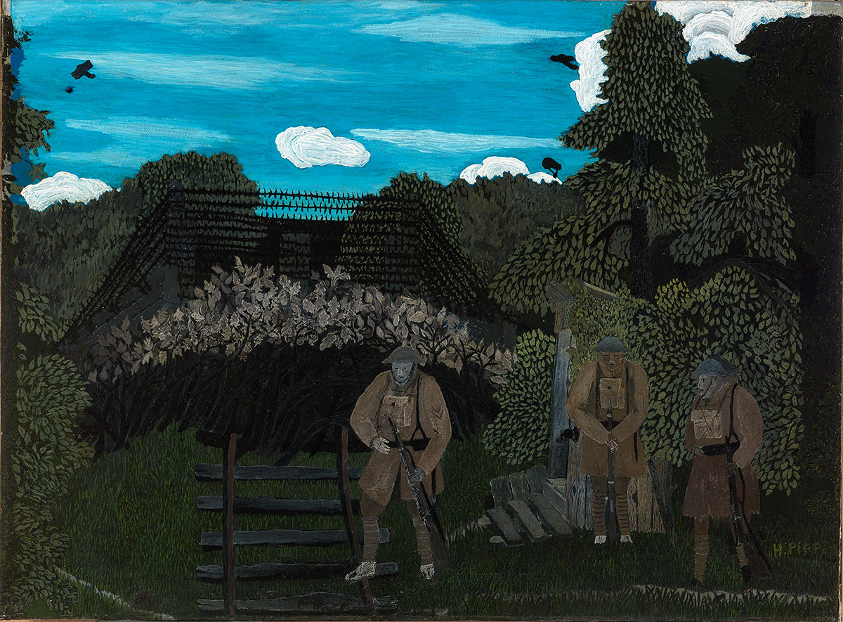
Source 1: Gas Alarm Outpost, Argonne, Horace Pippin
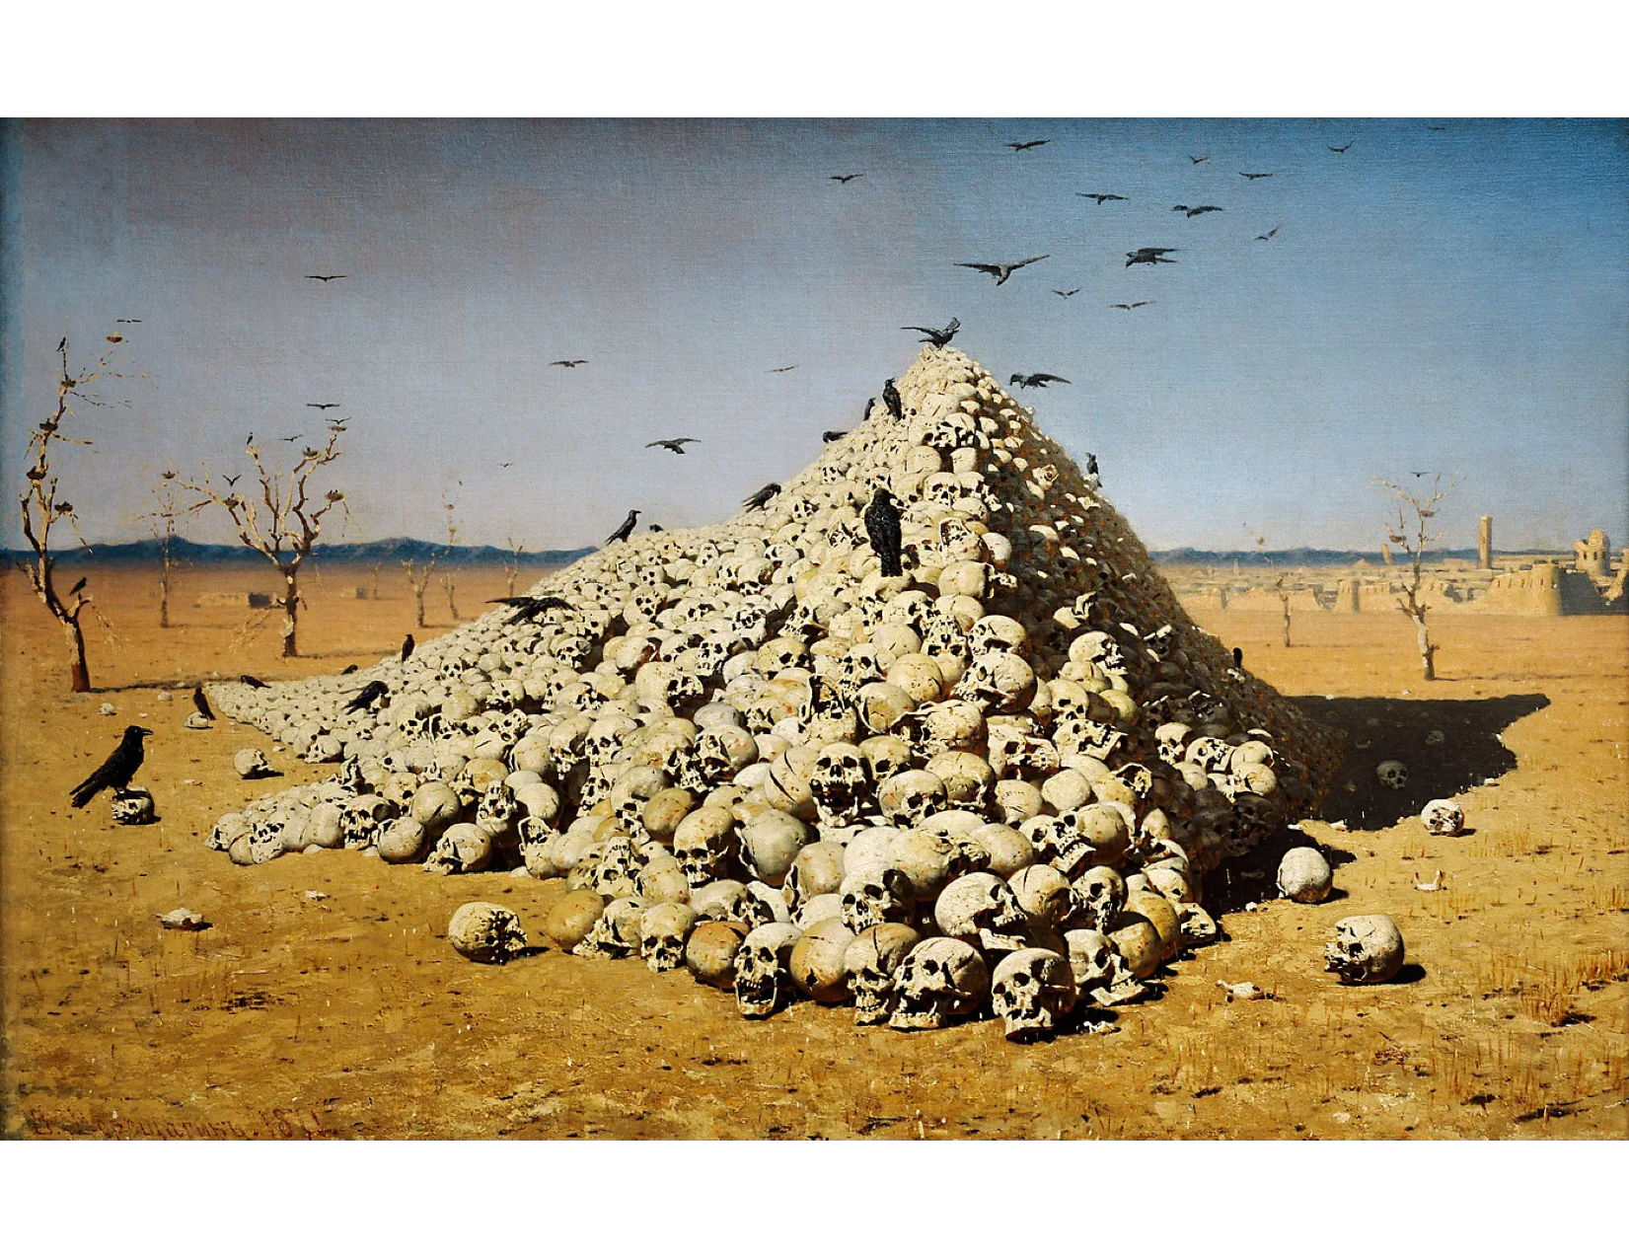
Source 2: The Apotheosis of War, Vasily Vereshchagin

Source 3: Napoléon on the Battlefield of Eylau, Antoine-Jean Gros
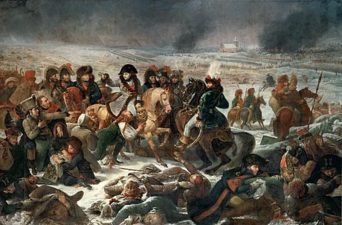

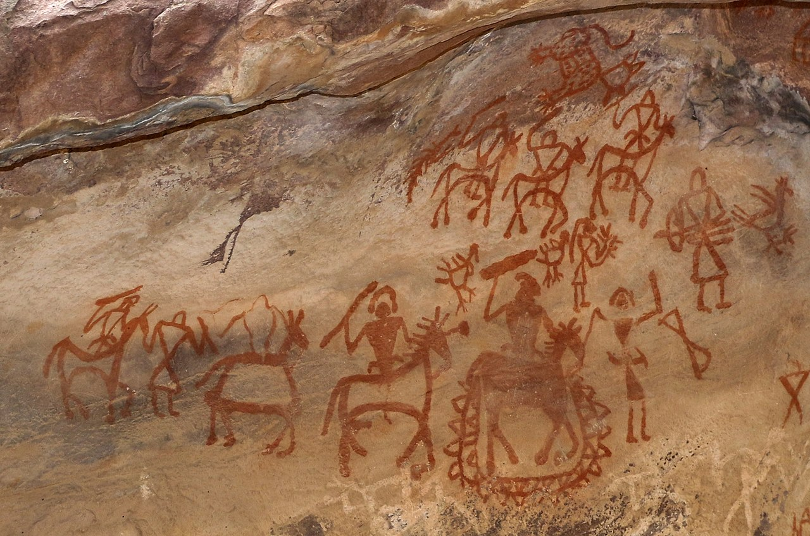
Source 4: Bhimbekta War Scene, Unknown Artist
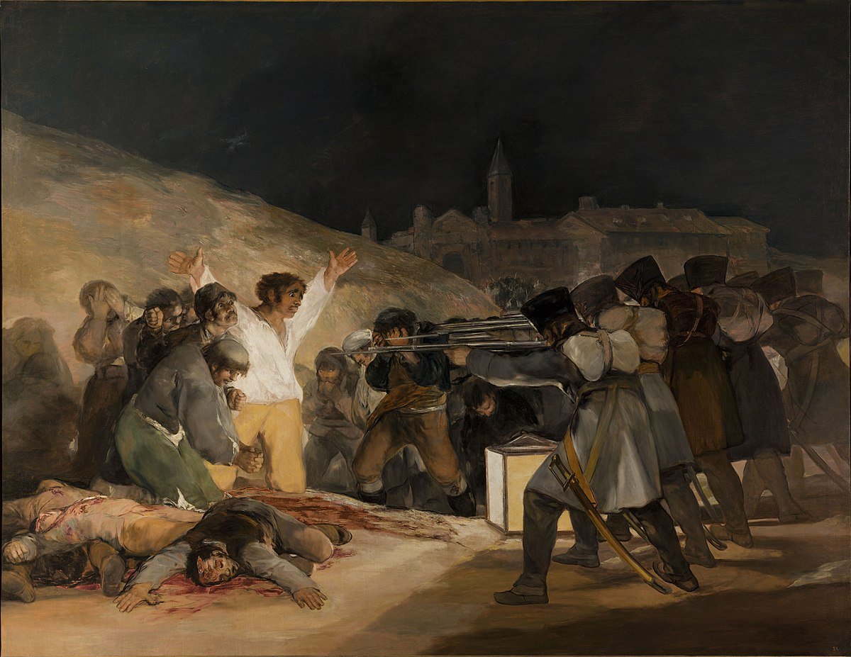
Source 5: El Tres de Mayo, Fransisco Goya

Source 6: The Flemish Apocalypse, Unknown Artist
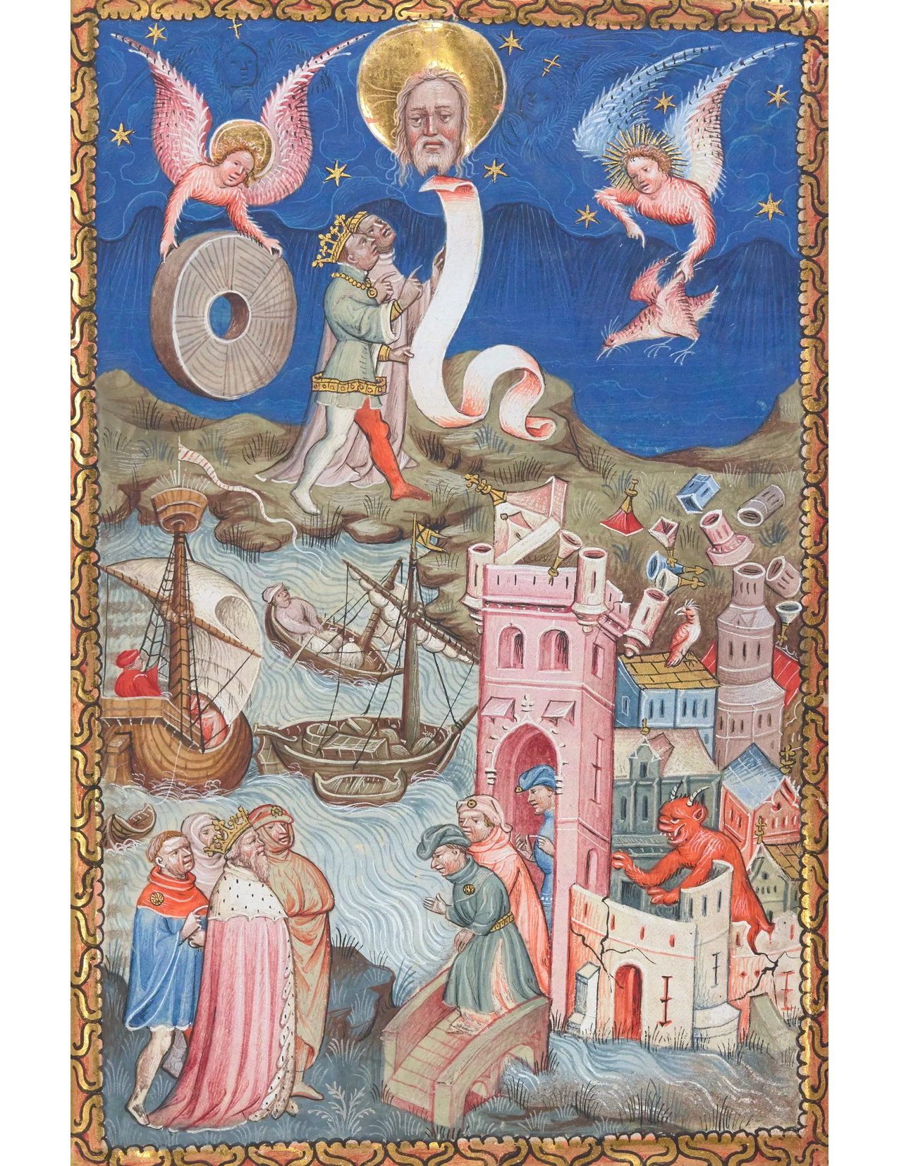

Figure 2 (“The Death Bed” by Siegfried Sassoon)

The Death Bed
by Siegfried Sassoon

He drowsed and was aware of silence heaped
Round him, unshaken as the steadfast walls;
Aqueous like floating rays of amber light,
Soaring and quivering in the wings of sleep.
Silence and safety; and his mortal shore
Lipped by the inward, moonless waves of death.

Someone was holding water to his mouth.
He swallowed, unresisting; moaned and dropped
Through crimson gloom to darkness; and forgot
The opiate throb and ache that was his wound.
Water—calm, sliding green above the weir;
Water—a sky-lit alley for his boat,
Bird-voiced, and bordered with reflected flowers
And shaken hues of summer: drifting down,
He dipped contented oars, and sighed, and slept.

Night, with a gust of wind, was in the ward,
Blowing the curtain to a gummering curve.
Night. He was blind; he could not see the stars
Glinting among the wraiths of wandering cloud;
Queer blots of colour, purple, scarlet, green,
Flickered and faded in his drowning eyes.

Rain—he could hear it rustling through the dark;
Fragrance and passionless music woven as one;
Warm rain on drooping roses; pattering showers
That soak the woods; not the harsh rain that sweeps
Behind the thunder, but a trickling peace,
Gently and slowly washing life away.

He stirred, shifting his body; then the pain
Leaped like a prowling beast, and gripped and tore
His groping dreams with grinding claws and fangs.
But someone was beside him; soon he lay
Shuddering because that evil thing had passed.
And death, who'd stepped toward him, paused and stared.

Light many lamps and gather round his bed.
Lend him your eyes, warm blood, and will to live.
Speak to him; rouse him; you may save him yet.
He's young; he hated war; how should he die
When cruel old campaigners win safe through?

But death replied: “I choose him.” So he went,
And there was silence in the summer night;
Silence and safety; and the veils of sleep.
Then, far away, the thudding of the guns.

Figure 3 (“Fixin to Die Rag” by Country Joe and the Fish)

Yeah, come on all of you big strong men,
Uncle Sam needs your help again.
He's got himself in a terrible jam
Way down yonder in Vietnam
So put down your books and pick up a gun,
We're gonna have a whole lotta fun.

And it's one, two, three,
What are we fighting for?
Don't ask me, I don't give a damn,
Next stop is Vietnam;
And it's five, six, seven,
Open up the pearly gates,
Well there ain't no time to wonder why,
Whoopee! we're all gonna die.

Well, come on generals, let's move fast;
Your big chance has come at last.
Gotta go out and get those reds -
The only good commie is the one who's dead
And you know that peace can only be won
When we've blown 'em all to Kingdom Come.

And it's one, two, three,
What are we fighting for?
Don't ask me, I don't give a damn,
Next stop is Vietnam;
And it's five, six, seven,
Open up the pearly gates,
Well there ain't no time to wonder why
Whoopee! we're all gonna die.

Huh!

Well, come on Wall Street, don't move slow,
Why man, this is War-a-go-go.
There's plenty good money to be made
By supplying the Army with the tools of the trade,
Just hope and pray that if they drop the bomb,
They drop it on the Viet Cong.

And it's one, two, three,
What are we fighting for?
Don't ask me, I don't give a damn,
Next stop is Vietnam.
And it's five, six, seven,
Open up the pearly gates,
Well there ain't no time to wonder why
Whoopee! we're all gonna die.

Well, come on mothers throughout the land,
Pack your boys off to Vietnam.
Come on fathers, don't hesitate,
Send 'em off before it's too late.
Be the first one on your block
To have your boy come home in a box.

And it's one, two, three
What are we fighting for?
Don't ask me, I don't give a damn,
Next stop is Vietnam.
And it's five, six, seven,
Open up the pearly gates,
Well there ain't no time to wonder why,
Whoopee! we're all gonna die.

Schrader, Benjamin. “Living War, Writing War, Teaching War.” Critical Military Studies 9, no. 1 (2023): 59.
Schrader, Benjamin. “Living War, Writing War, Teaching War.” Critical Military Studies 9, no. 1 (2023): 60.
Rachel Treisman, “U.S. Students Are Clashing Over The Israel-Hamas War. What Can Colleges Do?,” NPR, October 14, 2023, https://www.npr.org/2023/10/14/1205809697/israel-gaza-college-campus-protests-statements.
Gross, Jan T., Revolution From Abroad: The Soviet Conquest of Poland's Western Ukraine and Western Belorussia - Expanded Edition. Princeton, NJ :: Princeton University Press, 2021.
Toros, Harmonie, Daniel Dunleavy, Joe Gazeley, Alex Guirakhoo, Lucie Merian, and Yasmeen Omran. “‘Where Is War? We Are War.’ Teaching and Learning the Human Experience of War in the Classroom.” International studies perspectives. 19, no. 3 (2018): 200.
Benjamin Nathans, To the Success of Our Hopeless Cause: The Many Lives of the Soviet Dissident Movement (Princeton, 2024): 9.
Toros, Harmonie, Daniel Dunleavy, Joe Gazeley, Alex Guirakhoo, Lucie Merian, and Yasmeen Omran. “‘Where Is War? We Are War.’ Teaching and Learning the Human Experience of War in the Classroom.” International studies perspectives. 19, no. 3 (2018): 201
Toros, Harmonie, Daniel Dunleavy, Joe Gazeley, Alex Guirakhoo, Lucie Merian, and Yasmeen Omran. “‘Where Is War? We Are War.’ Teaching and Learning the Human Experience of War in the Classroom.” International studies perspectives. 19, no. 3 (2018): 214
ibid: 215
ibid: 215
Mark Newman. 2014. Vital Witnesses : Using Primary Sources in History and Social Studies. Lanham: Rowman & Littlefield Publishers: viii
Mark Newman. 2014. Vital Witnesses : Using Primary Sources in History and Social Studies. Lanham: Rowman & Littlefield Publishers: xviii
Peters, William. 2020. “Film in History Education: A Review of the Literature.” The Social Studies 111 (6): 275–276
Sospedra-Roca, Rafael, Francesc Xavier Hernàndez-Cardona, and Mar Hernàndez-Pongiluppi. 2022. “Digital Iconography, Conflict Heritage, and the Teaching of History: The Case of the Spanish Civil War.” Cogent Education 9 (1)
Winn, James Anderson, The Poetry of War. Cambridge: Cambridge University Press, 2008: 11
Winn, James Anderson, The Poetry of War. Cambridge: Cambridge University Press, 2008: 8
Winn, James Anderson, The Poetry of War. Cambridge: Cambridge University Press, 2008: 1

